Title | Analog Input Software Subsystem Requirements Specification
Distribution | Software Archive
Author | Spring Zhou,  Jax Yang |  | Date | 2015-12-15
Review | See review section |  | Date | See review section
Approved |  |  | Date
Remarks | All Requirements will be implemented as defined in this document and tested accordingly.
Contents

1 Introduction 3
1.1 Scope 3
1.2 Definitions, acronyms, and abbreviations 3
1.3 Document conventions 4
2 Overall description 4
3 Assumptions and dependencies 4
3.1 Assumptions 4
3.2 Dependencies 4
4 Non-functional requirements 4
4.1 General 4
4.2 Software Verification and Validation 5
4.3 Others 6
5 Functional requirements 6
5.1 Standard 4~20mA process 6
5.2 Diagnosis 7
6 Performance/accuracy requirements 8
7 Design constraints 8
8 Safety Requirements / Error-detection and error-handling 8
9 Manufacturing 8
10 Other requirements 8
11 Risks 8
12 Plan by stages 8
13 Testability Issues 8
14 References 8
15 Revision History 8
16 Requirement Review 9
16.1 Decision of the Review: 9
16.2 Check list: 9
16.3 Remarks: 9
16.4 Defects 9
16.5 Changes are proved: 10

List of Figures

Figure 1 Use case 3

List of Tables

No table of figures entries found.

Introduction

Scope
This document is intended to specify the software requirements for the Analog Input Subsystem. The Analog input Subsystem is part of the VT5 Project.
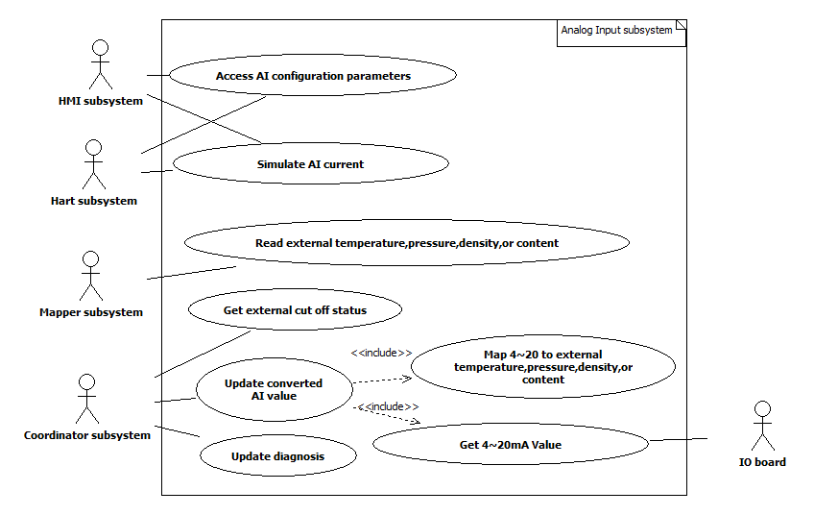
Figure 1 Use case

Definitions, acronyms, and abbreviations

AI | Analog Input
HMI subsystem | A subsystem handle with the communication with HMI Board
Hart subsystem | A subsystem handle with the Hart communication with other devices
Mapper | A subsystem which map device variables and diagnosis to HART/HMI
Coordinator | A subsystem handle with the task process, system management
IO Board | A hardware system which handle with 4~20mA current to voltage converting, AD converting, and digital outputting
Code generation tools | Some software tools distributed with the Framework, it includes EntryTool.exe, HMIGen.exe, and etc.
Framework | The framework used for all measurement project, it contains the code generate tools and a code base for the basic data types.

Document conventions
Software requirements are identified using the following in-line table format:
Ident. | Definition / Motivation | Priority | Source
 |  | Stability | Source
Each field is described in the following list:
Ident. a unique identifier for the Requirement
Priority one of: Mandatory / Desirable / Future
Stability one of: Committed (Agreed by approvers) / Not yet agreed / Likely to change

Overall description

Analog Input subsystem sample 4-20mA signal, map the signal value for temperature, pressure, density or gas content according to analog input mode configuration, and implement process diagnosis.

Assumptions and dependencies
All the requirements are derived from VT5 software requirement specification [1] and VT5 F/W design specification [2]

Assumptions

xx

Dependencies

- The Analog Input Subsystem will be developed for VT5 project.
- Development and testing will be done regarding to the following conditions:

  - Compiler: IAR compiler v3.4
  - Framework: 2.3.1
  - Oscillator frequency: 3.686 MHz
  - System update rate / execution time: 500ms

Non-functional requirements

General
Ident. | Definition / Motivation | Priority  M | Source  [RS004] 3.1.1
ANAS_NFR1 | The software shall be written in c language or assembly language. | Stability  C | Source  [RS004] 3.1.1

Ident. | Definition / Motivation | Priority  M | Source  [RS004] 3.1.2
ANAS_NFR2 | The system shall be developed on M16CR5F363AM. | Stability  C | Source  [RS004] 3.1.2

Ident. | Definition / Motivation | Priority  M | Source  [RS004] 3.1.4
ANAS_NFR3 | Four documents shall be created for Analog Input subsystem:  - Software requirement specification,  - Software design description,  - Software test plan and test report,  - Software code review. | Stability  C | Source  [RS004] 3.1.4

Software Verification and Validation
Ident. | Definition / Motivation | Priority  M | Source  [RS004] 3.2.1
ANAS_NFR4 | The static code analysis of c code shall be performed with the PC Lint tool and passed with the warning level 3. | Stability  C | Source  [RS004] 3.2.1

Ident. | Definition / Motivation | Priority  M | Source  [RS004] 3.2.2
ANAS_NFR5 | - The “Module Test” in this project scope will check the operations and their relations within the system.  - If required, a specific test container environment could be used to simulate the module input signal.  - The Module test will be done by the developer and reviewed with the code review procedure.  - The Module tests shall cover all implemented functions. | Stability  C | Source  [RS004] 3.2.2

Ident. | Definition / Motivation | Priority  M | Source  [RS004] 3.2.3
ANAS_NFR6 | For the “Code Review” procedure a second developer shall check the implementation by using the code review questionnaire and his experience about embedded software behaviour.  The code review shall be carried out for the complete subsystem code. | Stability  C | Source  [RS004] 3.2.3

Others
Ident. | Definition / Motivation | Priority  M | Source  [RS004] 3.3.1
ANAS_NFR7 | Dynamic memory allocation shall not be used to avoid allocation or deallocation problems. | Stability  C | Source  [RS004] 3.3.1

Ident. | Definition / Motivation | Priority  M | Source  [RS004] 3.3.2
ANAS_NFR8 | The system shall provide a method to read and write all the parameters of the device. | Stability  C | Source  [RS004] 3.3.2

Ident. | Definition / Motivation | Priority  M | Source  [RS004] 3.3.2
ANAS_NFR9 | Compiler optimization is not permitted | Stability  C | Source  [RS004] 3.3.2

Functional requirements

Standard 4~20mA process
Ident. | Definition / Motivation | Priority  M | Source  [RS004] 4.13.1
ANAS_SP1 | Read 4-20 mA signal data | Stability  C | Source  [RS004] 4.13.1

Ident. | Definition / Motivation | Priority  M | Source  [RS004] 4.13.1
ANAS_SP2 | Map the 4~20mA signal data for process values according to the subsystem mode configuration:  1) external Temperature  2) Pressure  3) Pressure (abs)  4) Gas content  5) Density  6) internal Temperature | Stability  C | Source  [RS004] 4.13.1

Ident. | Definition / Motivation | Priority  M | Source  [RS004] 4.13.2
ANAS_SP3 | AI shall provide a selection to configure the mode. The selection for AI:  1) external Temperature  2) Pressure  3) Pressure (abs)  4) Gas content  5) Density  6) external output cut off  7) Without  8) internal Temperature | Stability  C | Source  [RS004] 4.13.2

Ident. | Definition / Motivation | Priority  M | Source  [RS004] 4.13.3
ANAS_SP4 | The analog input signal valid range is 3.8~20.5 mA.  Generate Error If the input is beyond the range. | Stability  C | Source  [RS004] 4.13.3

Ident. | Definition / Motivation | Priority  M | Source  RD
ANAS_SP5 | AI shall provide 3 cut off options:  - 4mA  - 8mA  - 12mA  If the analog input current is greater than the cut off current selected when AI selected as external output cut off, AI shall generate a cut off message. | Stability  C | Source  RD

Diagnosis
Ident. | Definition / Motivation | Priority  M | Source  [RS004] 4.11.1, 4.11.17
ANAS_D1 | AI shall support error detection as below when it’s not selected as without:  - SPI communication error if AI cannot read data from AD converter.  - AI out of range error if analog input is not in the range of 3.8~20.5mA  - AI cut off error if AI cut off occurred. | Stability  C | Source  [RS004] 4.11.1, 4.11.17

Performance/accuracy requirements
xx

Design constraints
This should specify design constraints that can be imposed by other standards, hardware limitations, Interfaces to other applications, Parallel operation, Control functions etc.
xx

Safety Requirements / Error-detection and error-handling

Manufacturing
This section should specify constraints and requirements for the manufacturing.
Xx

Other requirements
xx

Risks
xx

Plan by stages
This section should specify steps for the realisation of the required functionality.
Xx

Testability Issues
This section should specify 8estability issues, e.g. required standards, environment, training and resources.
Xx

References
Ref. | Document
[1] | [RS004] VT5 software requirement specification.
[2] | [DS002] VT5 F/W design specification.

Revision History
Rev. | Description of Version/Changes | Primary Author(s) | Date
0.1 | Initial revision. | Spring Kunli.Zhou | 2011-08-11
0.2 | Update the document according to [RS004] | Jax Yang | 2012-05-15
0.3  0.4 | Update the document according to reviewer’s comments  Modify the document based on architecture | Jax Yang  Jax Yang | 2012-05-18  2013-05-27
0.5 | Modify the document according to Spring’s review | Jax Yang | 2013-06-19
0.6  0.7 | Update overall description in section 2  Add internal Temperature selection(ANAS_SP2 and ANAS_SP3) | Jax Yang  Lawrence Shi | 2014-01-06  2015-12-15

Requirement Review
Dept. | Name
R&D ShangHai | Zuochen Wang, Merrick Huang | 2013-05-18 rev0.3

Dept. | Name
R&D ShangHai | Spring Zhou, Vincent Liu | 2013-05-27 rev0.4

Dept. | Name
R&D ShangHai | Spring Zhou, Vincent Liu | 2013-06-19 rev0.5

Dept. | Name
R&D ShangHai | Merrick Huang | 2014-01-06 rev0.6

Dept. | Name
R&D ShangHai | Merrick Huang | 2015-12-15 rev0.7

Decision of the Review:

 | Decision | next steps
 | Inspection passed without restrictions | Phase finished
X | Inspection passed with restrictions | some changes must be done
 | Inspection not passed | Inspection must be repeated

Check list:
 |  | yes | no | N.A.
1. | Does the specification explain the currently known requirements that the product finally has to perform? | Y
2. | Are complex subjects explained? | Y
3. | Are all used abbreviations and technical expressions explained? | Y
4. | Are all referenced documents in the reference list? | Y
5. | Contains the document a rough overview of the product’s main functionality? | Y
6. | Are all requirements referenced? | Y
7. | Are all requirements testable? | Y
8. | Is the typical environment of the product described? | Y
9. | Is defined which components already exist, will be bought or self-written? | Y
10. | Are safety requirements (e.g error-detection, error-handling) specified? | Y
11. | Are service/update requirements described? | Y
12. | Are all dependencies to other requirement documents considered? | Y
13. | Are templates used in a correct manner? | Y
14. | Are all open issues transferred to the defects table? | Y

Remarks:

Defects
No. | Checkpoint | Description | Major Defect | done  Date
1 | 1.1 | Modify the use case diagram because the previous version have some mistakes:  - Figure 1 doesn’t include Hart subsystem. Hart subsystem is the user that configure AI mode and configure unit/range.  - HMI can simulate the AI input. This action is not included in Figure 1.  - Other subsystem is implicit in Figure1.  - User is implicit in Figure 1. | Y | 2012-5-18
2 | 1.2 | Update the term according the new use case diagram | Y | 2012-5-18
3 | 2 | Modified the system overall description. The previous version doesn’t describe the system clearly. | Y | 2012-5-18
4 | 3.1 | Delete the Assumptions description |  | 2012-5-18
4 | 5.1  ANAS_GR2 | Delete this item because it’s no need describe it in requirement document. |  | 2012-5-18
5 | 5.2  ANAS_SP1 | Describe the requirement item in details to make it more clearly. | Y | 2012-5-18
6 | 5.2 ANAS_SP3 | Describe the requirement item in details to make it more clearly. | Y | 2012-5-18
7 | 5.2  ANAS_SP4 | Modify the description to make it more clearly. |  | 2012-5-18
8 | 5.2  ANAS_SP5 | Use the full unit name instead of abbreviations. |  | 2012-5-18
9 | 5.2  ANAS_SP2 | Modify the description to make it more clearly. |  | 2012-5-18
10 | 1.1 | Modify the use case diagram |  | 2013-5-27
11 | 5.2  ANAS_SP3 | Add external cut off option |  | 2013-5-27
12 | 5.2  ANAS_SP4 | Modify the analog input valid range from 4~20 to 3.8~20.5 |  | 2013-5-27
13 | 5.2  ANAS_SP5 | Describe the external cut off feature in details |  | 2013-5-27
14 |  | Move the ANAS_SP5 ~ ANAS_SP8 and ANAS_SP12 to mapper |  | 2013-5-27
15 |  | Delete ANAS_SP9, ANAS_SP13, ANAS_SP14 |  | 2013-5-27
16 | ANAS_SP4 | “invalid range is …” shall be “valid range” |  | 2013-6-19
17 | ANAS_NFR3 | Merge test plan and test report as one document |  | 2013-6-19
18 |  | Modify the overall description in section 2 |  | 2014-01-06

Changes are proved:
The Reviewer confirms that all changes are done:
Proved Rev: | Date: | Reviewer:
0.5 | 2013-06-19 | Spring Zhou  Vincent Liu
0.6 | 2014-01-06 | Merrick Huang
0.7 | 2015-12-15 | Merrick Huang

